Risk KAN Working Group:

Risks from Human Responses to Climate Change

**Leads:** Lisa Thalheimer (IIASA), Nick Simpson (University of Cape Town)

**Rationale**

* Much of Risk KAN's work has been hazard-focused. However, the severity of climate change impacts can equally be determined by human responses to climate change, or lack thereof.
* This is an important update, in line with the revised IPCC definition of risk, which includes responses (both mitigation and adaptation).
* Focusing on responses can help move thinking from hazards through impacts to actionable knowledge and more equitable solutions as well as clarify concerns over risk to response for both researchers and policymakers.

**Aim**

Our working group aims to provide a research and funding networking platform for climate risk research focusing on human responses to climate change. It seeks to clarify our understanding of how adaptation and mitigation responses affect specific climate change risks (reduce, avoid, displace or increase), how they affect other responses (eg. how adaptation and mitigation affect each other) or where they are making risks worse (eg. maladaptation or malmitigation, and more extreme responses such as Solar Radiation Management). Human responses to climate change are diverse and evolving. The initial focus of the group includes human mobility and immobility in the context of climate change, education, wellbeing and health. This working group draws on extreme and compound events to unpack the multifaceted ways in which people and nature are impacted by responses. This working group is therefore climate change-impact focused.

Additional points:

* Climate change responses affect dimensions of hazard, exposure, and vulnerability.
* Bringing interdisciplinary and globally diverse climate impact researchers together
* Extending both quantitative and qualitative approaches to deepen understanding of risk
* Impact attribution and the effects of responses to climate change in impact attribution

**Planned activities**

* Goal: align with existing activities in our work, e.g, [CLIMAKID](https://www.pik-potsdam.de/en/output/projects/all/1086) impact attribution; CCMIG-EU; Nick as Lead Author of Ch. 1 (risk framing) the IPCC Special Report on Climate Change and Cities and AR7; Global Adaptation Mapping Initiative 2.0 (Global systematic stocktake of evidence of human responses to climate change 2025-2028).
* Quarterly presentations by researchers in our networks
* Identify funding opportunities with working group members through a living document (e.g., Google docs)

**Working group members** see [WG members_Risks from Human Responses to Climate Change](https://docs.google.com/spreadsheets/d/1a7GgKb4kyKReoi9AZD-uNVRNue_cGZ5qeG_wM77kruk/edit?usp=sharing)

* Lisa Schipper
* Chris Trisos
* Raed Hamed
* Sophie Buijs
* Steffen Lohrey (tbc)
* Laurel DiSera (tbc)
* Sofia Bandini
* Christoper Trisos
* To reach out to Katherine Mach’s group, Michael Oppenheimer’s group and Amir AghaKouchak’s group

Risk KAN Working Group on Migration and Climate Solutions

**Risks from Human Responses to Climate Change**

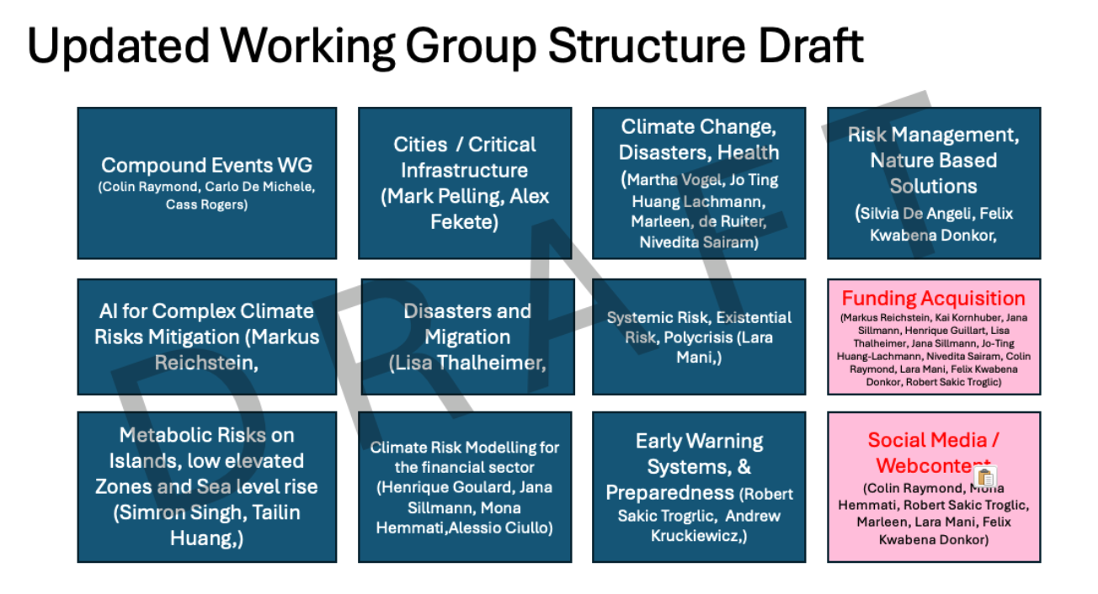

**4 steps until April 21st**

1. *Connect with your co-lead (in case you are the only lead feel free to connect with us to discuss a potential co - lead you might have in mind) ✅*
2. *Discuss Specify* ***Working Group Name*** *with your co-lead (and group if formed).* 
   1. *Discuss addition of education/ well-being, health, heritage, sport and biodiversity, impact attribution ✅*
3. *Start building your Working Group under consideration of the diversity considerations listed above, for this please reach out first to those that have indicated interest in becoming an active group member in the survey, see preferences in column '****Active Member Interest****' in doc. attached for candidates that are interested to join your WG)*
4. *Write or update a* ***Working group mission statement*** *document (1-2 pages, listing working group name, leads, members, structured by paragraphs titled* ***Rational, Aims, planned Activities****).*